**Nate Matteson: Front-end development of phylogenetic display**

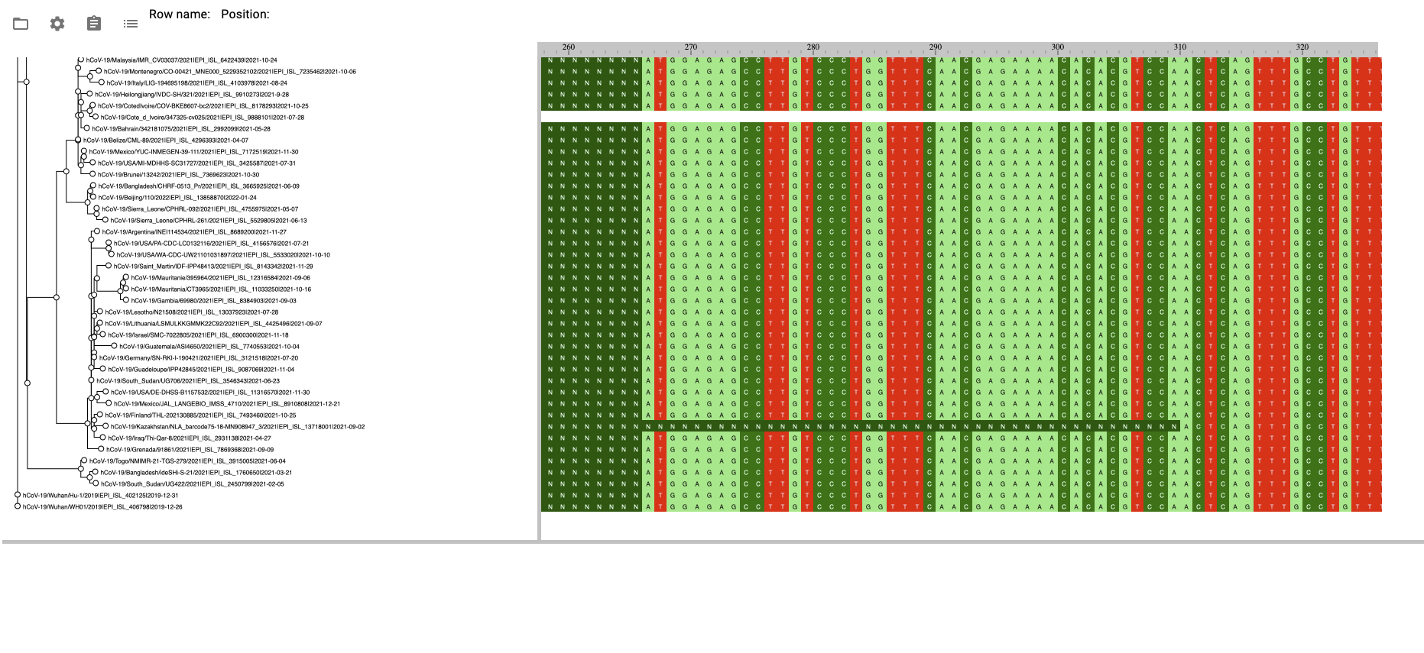

After comparing available phylogenetic tree visualization software for suitability to be extended towards our goals, I selected and made a demo website using react-msaview (see screenshot above) which loads and displays a tree and alignment from file.